Mind, Brain, and Models

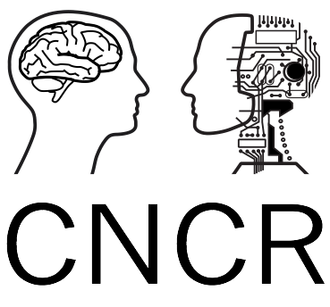
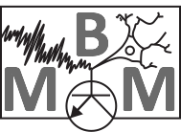
Cerebellum and Motor Control
Part 1

In the lecture we learnt about how state-space models are able to explain cerebellar-dependent model-based learning. In the lab, you will gain experience of fitting a 1-state and 2-state model onto 5 participant’s data who had experienced a visuomotor adaptation.
Download the state_space_model.m. getrow.m and T.mat files. The T.mat file is the data. The state_space_model.mat file introduces the case function which is a simple way of performing different functions within the same code. You will also need the getrow function. You can run either a 1-state model with the command:
y= state_space_lecture('fit_all_ss')

Or a 2-state model with:
y= state_space_lecture('fit_all_ts')

Create a single word document that includes all figures, code and answers requested.

- Run the 1-state model: The 1-state model is set up to run subject 1 however is currently missing the B (learning) component (line 28). Based on:

Z^{(n+1)} = A z^{n} + B (D.u^{n} –z^{n})

Complete line 28 and submit this line of code.

- Complete the 2-state model: The 2-state function (‘fit_all_ts’) has a line missing; line 69. This relates to the updating of the slow state (zs). Based on:

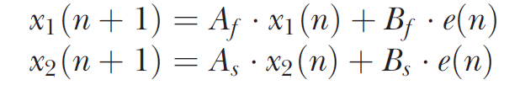

and how the fast state is updated on line 68, complete this line. Submit this line of code.

- Run the 2-state model: The model is set up to run subject 1. Run the model. Plot the raw data (y) against the model predicted data (yp) and the output of the fast system (state_fast) and slow system (state_slow). Submit this figure.

Part 2

- Next, change the A (retention) and B (learning) values in the model for the both the fast and slow system (‘fit_all_ts’). Do this one at a time, remembering to return the other values back to their original number. Plot these 4 predictions (yp) against the raw data. Submit this figure.

- Model comparison: Now you have a working 1-state and 2-state model. First return the 1-state and 2-state model to original values:
1-state = M.A=0.95, M.B=0.2.
2-state = M.A = [0.7 0.99] M.B = [0.15 0.02];

Run the models for each subject (you will need to work this out). Run each model for each participant. For each participant, create a figure which compares the raw data (y) with the predicted model (yp) from the 1-state and 2-state models. Submit the 5 figures.

- Model fit: Using matlab, could you perform some form of model comparison between these two models using the original values? Submit the details of your attempt at comparing the fit of the 2 models across participants (ie) function used, results.

- Adding a third state: Finally, can you add a third state to the 2-state model? Does this improve the fits across participants (using the same logic from question 5)? Submit the code which incorporates the third state and any model comparison data.

- Extra Challenge: This question will not be marked and is a challenge to demonstrate how researchers use these models in practice. As you can see in the individual data from question 4 individual participants learn at different rates and a model with a given set of parameters (A and B) will fit certain participants better than others. What we really want to do is to find the set of parameters that produce the best fit for each individual participant so we can compare these values between groups of participants. E.g. if we give a group of participants rewarding feedback will they have a different A or B parameter from a group without this feedback (see Galea et al 2015, Nat Neuro for this in practice). This is called model fitting or optimization. Can you develop a way to find the set of parameters (A and B) separately for each participant that lead to the best fit to their data (hint: you are trying to minimize the error in the model fits, see question 6).

